What are ethical frameworks?

As people in this world, and good citizens, we are concerned not only with what actions are morally right and morally wrong, but what makes actions morally right or morally wrong. The key is to understand the reasoning that we employ in ethical decision making so we can become more proficient.
Ethical frameworks are perspectives useful for reasoning what course of action may provide the most moral outcome. In many cases, a person may not use a reasoning process but rather do what they simply feel is best at the time. Others may reflexively use a principle they learned from their family, peers, religious teachings or own experiences. The study of ethics has provided many principles that can aid in ethical decision making. Some of the most common are captured in the following 5 ethical frameworks:
- Virtue ethics: What is moral is what makes us the best person we could be.
- Deontology: What is moral is what follows from absolute moral duties.
- Utilitarianism: What is morally right is what generates the best outcome for the largest number of people.
- Rights-based Ethics : What is moral is that which is in accord with everyone's rights.
- Care-based Ethics : What is moral is that which promotes healthy relationships and the well-being of individuals and their interdependence.
The reference videos provide a description of these.
Please remember that these and other ethical frameworks are considered differently by people from diverse societies around the world including Asian, African, Native American and others.

What is an ethical decision-making framework?

Ethical decision making may be the most important skill you develop in your life. Change in your life for the better or worse happens at decision points. Do I finish this assignment, take that class, go to that party, chose that college, etc. Some decisions have much deeper consequences. Like do I cheat on that test, lie to my parents, or follow along when someone asks me to do something I know is wrong.

Like any skill, however, proficiency requires an understanding of the technique and a lot of practice. No one becomes good at singing, playing an instrument or sport, or solving math or science problems without understanding how it’s done and spending a lot of time doing it.

So let’s start with a defined technique! Here is a formal process for making ethical decisions. Take the time to understand it.

Ethical decision-making process:

Look for and identify ethical issues. What feels wrong?

Obtain unbiased facts and look for distorted or missing information.

Identify the stakeholders and their motivation and influence. Understand situational factors.

Identify the values and look for competing values.

Seek additional assistance and foster open discussion. Reinforce the values of mutual respect and reason-giving.

Formulate solutions using best-known ethical frameworks as a guide.

Evaluate proposed alternatives including potential consequences.

Select and implement the most ethical solution.

Monitor and assess the outcome.

Work to avoid future problems.

Implementing the process

Becoming an expert at ethical decision making takes time! The 10 steps above are easy to remember, but using the process requires skill. It is like having someone show you the keys on a piano and explaining a sheet of music then asking you to play Beethoven’s Moonlight Sonata.

A bit of discussion on the process can help. The first step is key. You can miss a lot if you are not looking for it. You first need to develop a moral radar. When things are happening, you want to ask, is this ethical. Fortunately, most people have some level of ethics built in. It is your gut-reaction to situations. It is when you see something happening and it feels wrong. This is an indication that more analysis is needed.

Facts can be elusive. Do you know all you need to know to make a decision? Is what you know true? Is the information distorted or has the situation been framed in some way to obscure or downplay the ethical issue? What questions need to be asked? What are the larger issues? What is influencing the situation? For example, a student may have found the answer key to an exam. Wanting to make friends, he or she tries to share it with you. When your moral radar sounds the alarm that it may not be right to take it since it would not right and you refuse, they may say things like “several other students are using it” or “students do this all the time” or “you have to do what is necessary to get the best grade – don't you want to get into college?”. These framings can reduce the moral intensity.

Identifying stakeholders can be complex as it is easy to miss some at the moment a decision is needed. That’s why it is fine and sometimes needed to just stop and not make a decision until you are ready. Following the example above, you may already be thinking about the stakeholders like your friends who were not offered the exam solutions or the teacher who may find out. But what about your parents, family, others who may change their opinion of you if they find out, and even yourself as what if you then do not study and actually do not have the knowledge and skills the work would provide you that you will need for the next section or course?

When thinking about the stakeholders and collective situation, you need to be aware of situational factors that may be in play. Such factors include things like what is motivating the behaviors of the stakeholders like conflicts of interest, what levels of influence do certain stakeholders have over others, what stakeholders are powerful and what systemic issues are involved that may be involved with the ethical issue but not directly in sight. For example, for the current example, systemic issues could be how could the answer key become available in the first place or is the student who obtained the answers and trying to share them isolated and using the situation to gain friends.

Understanding the values at work in the ethical issue is key. Ethics emerges when values come into conflict. Some values can be elusive. For example, in the current case, many values are in conflict. The values of honesty and fairness are competing with accomplishment and wanting to retain the relationship with the person offering the exam solutions. Which would you value more?

To help you, here is a list of some common values:

Accomplishment, advancement, authority, autonomy, belonging to a group, beneficence, care, citizenship, compassion, control, duty, enjoyment, environment, equity, fairness, faith, family, freedom, friendship, happiness, honesty, justice, life, loyalty, meaning, nonmaleficence, opportunity to speak/express, peace, pleasure, power, profit, recognition, reparation, safety, sanctity, security, self-esteem, success, truth, unity, voice, wealth.

It is also a good idea to seek assistance when you are trying to make the right decision. You should look to people you trust and respect, and if you are afraid to talk about what is happening for any reason, it is a sign that the ethical issue is real and needs attention. You should never be afraid to speak about things that are going on in your life. Groups generally make better decisions than individuals, so talking to ethical, trustworthy people almost always helps.

Formulating solutions is tough. Often some values are given a lower priority than others. This is where the ethical frameworks can help. Would you be a person of good character if you used the exam solutions (Virtue ethics)? Would it violate any rules that you have a duty to uphold like you will not cheat and will not succumb to peer pressure (Deontology)? Does the outcome produce the most good for the most people, i.e., a few students get a good grade, but others do more poorly by comparison and those who cheated do not really know the material (Utilitarianism)? Did your actions violate anyone’s rights like the right of your classmates to have a fair exam (Rights-based ethics)? And how will your relationships with your classmates, friends, parents and others who find out you cheated (Care-based ethics)?

How do you monitor the outcome and avoid future problems? Perhaps informing the teacher that the answer key is available (even anonymously) so no one can cheat in the future? Or changing the way exams are created and solution keys stored so it would be impossibkle for a student to obtain them.

This is the ethical decision-making process. Here is a graphic for your use!

What do you think? Is anything missing? Can it be improved? Start practicing today!

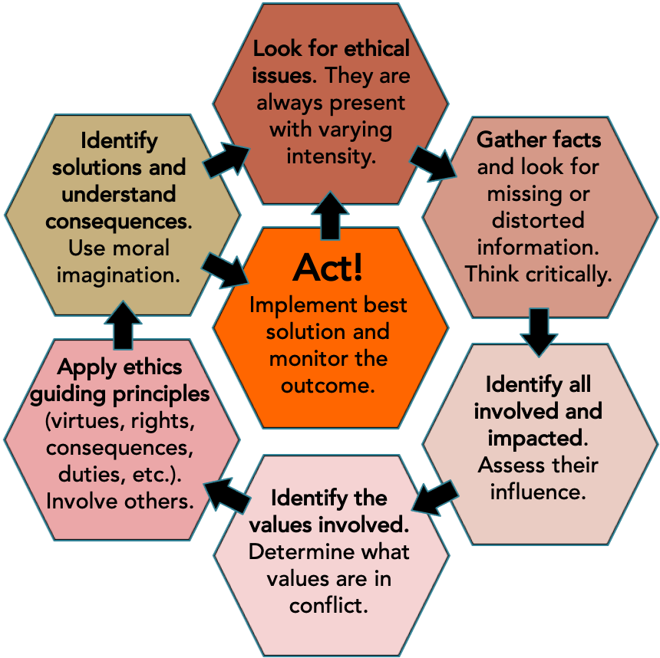
Worksheets:

NOTE: For all exercises, students can be asked to first complete the exercise and develop a solution individually, then in a group where the group must collectively decide on a solution. If there is disagreement in the group, they must be able to decide, perhaps using a final vote to select the best option. If this format is used you may add the following question at the end:

Question: Did your opinion change when completing the exercise in a group? If so, why? Did you reprioritize your values? Did you learn something you did not know previously? Did you gain a different perspective? How were you influenced?

Ethics case study 4: A frack-tured farm

Ethical decision to be made: Should the farm owners allow the company to set up a gas well on their property?
Background:

A mid-sized 460 acre farm in NE PA located directly adjacent to a small town of ~1200 people is having financial difficulty. They are barely profitable and profits are declining suggesting in 2-3 years the farm will be losing money each year resulting in it closing business. The farm employs 25 people plus family members.

The owners of the farm were approached by a large oil and gas company to obtain rights to recover natural gas located beneath the surface of their land using the process of hydraulic fracturing (fracking). The company would require 4-6 acres and road access to an optimal spot for drilling. A drilling and fracking rig plus a retention pool for the toxic fracking flowback fluid will be placed on the land. The oil and gas company assure the owners the process is safe and will not contaminate the water or land. The projected revenue from the new business will substantially increase the farm owner's income. With this income, the family may be able to invest into the farm infrastructure making the farm business profitable again, potentially allowing them to retain their employees or grow their employee base.

Hearing about this situation, a group of towns people investigate and learn that similar drilling operations from the same company in that region have resulted in well water contamination for properties near the fracking site. This contamination prevented owners from drinking the water or using it for bathing and other purposes. Owners of those properties have approached the oil and gas company about the situation and the oil and gas company denied any connection between their operations and the contamination. There are no known means of cleaning the contaminated water. Moreover, laws, specifically the Energy Policy Act of 2005, exempt oil and gas companies from being liable for drinking water contamination due to hydraulic fracturing. A more detailed investigation reveals that many other drilling operations are not contaminating nearby wells in other locations.

Given the proximity of the farm to the town, and the prevalence of well water use for several dozen town residences and businesses, the group petitions the farm owners to reject the oil and gas proposal.

Ethical decision-making process:
- What are the ethical issues? What does not feel right?
- What are the relevant facts? Is anything missing or distorted?
- Who are the stakeholders? What are their influence on the situation?
- What are the situational factors?
- What are the values in conflict?
- How do the ethical frameworks apply? Is anyone/any group not acting with virtue? Are any ethical rules being violated? How would the most benefit to the largest number of people be achieved? Should only people be considered?
- What are possible solutions? What are the consequences? What must be monitored in the future?
- What was your final solution and justification?

Implement your solution:

- Should the farm owners allow gas drilling and fracking on their land? Justify your answer.

